Software Engineering

What is Software Engineering?
The term software engineering is the product of two words, software, and engineering.
The software is a collection of integrated programs.
Software subsists of carefully-organized instructions and code written by developers on any of various particular computer languages.
Computer programs and related documentation such as requirements, design models and user manuals.
Engineering is the application of scientific and practical knowledge to invent, design, build, maintain, and improve frameworks, processes, etc.
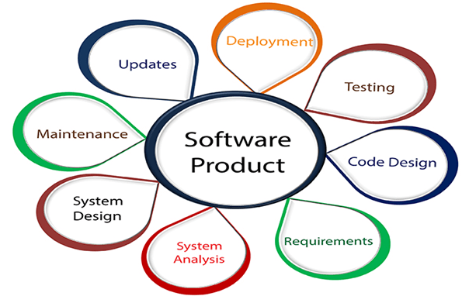
Software Engineering is an engineering branch related to the evolution of software product using well-defined scientific principles, techniques, and procedures. The result of software engineering is an effective and reliable software product.

Why is Software Engineering required?
Software Engineering is required due to the following reasons:
- To manage Large software
- For more Scalability
- Cost Management
- To manage the dynamic nature of software
- For better quality Management

Need of Software Engineering
The necessity of software engineering appears because of a higher rate of progress in user requirements and the environment on which the program is working.
- Huge Programming: It is simpler to manufacture a wall than to a house or building, similarly, as the measure of programming become extensive engineering has to step to give it a scientific process.
- Adaptability: If the software procedure were not based on scientific and engineering ideas, it would be simpler to re-create new software than to scale an existing one.
- Cost: As the hardware industry has demonstrated its skills and huge manufacturing has let down the cost of computer and electronic hardware. But the cost of programming remains high if the proper process is not adapted.
- Dynamic Nature: The continually growing and adapting nature of programming hugely depends upon the environment in which the client works. If the quality of the software is continually changing, new upgrades need to be done in the existing one.
- Quality Management: Better procedure of software development provides a better and quality software product.

Characteristics of a good software engineer
The features that good software engineers should possess are as follows:
Exposure to systematic methods, i.e., familiarity with software engineering principles.
Good technical knowledge of the project range (Domain knowledge).
Good programming abilities.
Good communication skills. These skills comprise of oral, written, and interpersonal skills.
High motivation.
Sound knowledge of fundamentals of computer science.
Intelligence.

Importance of Software Engineering
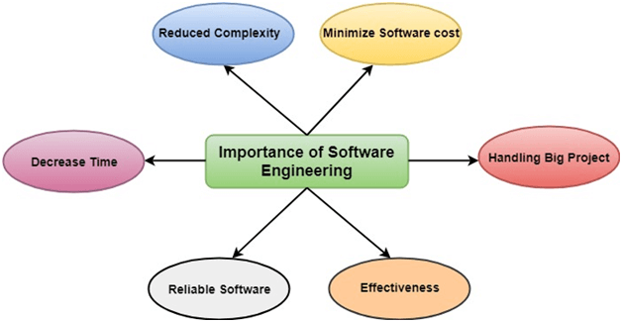
The importance of Software engineering is as follows:
- Reduces complexity: Big software is always complicated and challenging to progress. Software engineering has a great solution to reduce the complication of any project. Software engineering divides big problems into various small issues. And then start solving each small issue one by one. All these small problems are solved independently to each other.
- To minimize software cost: Software needs a lot of hardwork and software engineers are highly paid experts. A lot of manpower is required to develop software with a large number of codes. But in software engineering, programmers project everything and decrease all those things that are not needed. In turn, the cost for software productions becomes less as compared to any software that does not use software engineering method.
- To decrease time: Anything that is not made according to the project always wastes time. And if you are making great software, then you may need to run many codes to get the definitive running code. This is a very time-consuming procedure, and if it is not well handled, then this can take a lot of time. So if you are making your software according to the software engineering method, then it will decrease a lot of time.
- Handling big projects: Big projects are not done in a couple of days, and they need lots of patience, planning, and management. And to invest six and seven months of any company, it requires heaps of planning, direction, testing, and maintenance. No one can say that he has given four months of a company to the task, and the project is still in its first stage. Because the company has provided many resources to the plan and it should be completed. So to handle a big project without any problem, the company has to go for a software engineering method.
- Reliable software: Software should be secure, means if you have delivered the software, then it should work for at least its given time or subscription. And if any bugs come in the software, the company is responsible for solving all these bugs. Because in software engineering, testing and maintenance are given, so there is no worry of its reliability.
- Effectiveness: Effectiveness comes if anything has made according to the standards. Software standards are the big target of companies to make it more effective. So Software becomes more effective in the act with the help of software engineering.

Software Myths in Software Engineering
Software Myths are beliefs that do not have any pure evidence. Software myths may lead to many misunderstandings, unrealistic expectations, and poor decision-making in software development projects. Some common software myths include:
- The Myth of Perfect Software: Assuming that it's possible to create bug-free software. In Reality, software is inherently complex, and it's challenging to eliminate all defects.
- The Myth of Short Development Times: Assuming that software can be developed quickly without proper planning, design, and testing. In Reality, rushing the development process can lead to better-quality software and missed deadlines.
- The Myth of Linear Progression: The Development of software is in a linear, predictable manner. In Reality, development is often iterative and can involve unexpected setbacks and changes.
- The Myth of No Maintenance: It is thought that software development is complete once the initial version is released. But in reality, the software requires maintenance and updates to remain functional and secure.
- The Myth of User-Developer Mind Reading: It is assumed that developers can only understand user needs with clear and ongoing communication with users. But in reality, user feedback and collaboration are essential for correct software development.
- The Myth of Cost Predictability: It is thought that the cost of the software can be easily predicted, but in reality, many factors can influence project costs, and estimates are often subject to change. There are many hidden costs available.
- The Myth of Endless Features: It is believed that adding more features to software will make it better. But in reality, adding more features to the software can make it complex and harder to use and maintain. It may often lead to a worse user experience.
- The Myth of No Testing Needed: It is assumed that there is no need to test the software if the coder is skilled or the code looks good. But in reality, thorough testing is essential to catch hidden defects and ensure software reliability.
- The Myth of One-Size-Fits-All Methodologies: Thinking that a single software development methodology is suitable for all projects. But in reality, different methodologies should be used on the specific project.
- The Myth of "We'll Fix It Later": It is assumed that a bug can be fixed at a later stage. But in reality, as the code gets longer and bigger, it takes a lot of work to find and fix the bug. These issues can lead to increased costs and project delays.
- The Myth of All Developers Are Interchangeable: It is believed that any developer can replace another without any impact. But in reality, each developer has unique skills and knowledge that can significantly affect the project. Each one has a different method to code, find, and fix the bugs.
- The Myth of No User Training Required: It is assumed that users will understand and use new software without any training. But in reality, users need training and documentation to use the new software because the different methods used by different developers can be unique.
- More Developers Equal Faster Development: It is believed that if there are large no of coders, then the software development would take less time, and the quality of the software would be of high quality. But in reality, larger teams can lead to communication overhead and may only sometimes result in faster development.
- Perfect Software Is Possible: The Idea of creating completely bug-free software is a myth. In Reality, software development is complex, and it's challenging to eliminate all defects.
- Zero-Risk Software: It is assumed that it's possible to develop software with absolutely no risks. But in reality, all software projects involve some level of risk, and risk management is a critical part of software development.
Understanding and addressing these software myths is important for successful software development projects. It helps in setting realistic expectations, improving communication, and making more informed decisions throughout the development process.

Waterfall Model – Software Engineering

The classical waterfall model is the basic software development life cycle model. It is very simple but idealistic. Earlier this model was very popular but nowadays it is not used. However, it is very important because all the other software development life cycle models are based on the classical waterfall model.

What is the SDLC Waterfall Model?
The waterfall model is a software development model used in the context of large, complex projects, typically in the field of information technology. It is characterized by a structured, sequential approach to project management and software development.
The waterfall model is useful in situations where the project requirements are well-defined and the project goals are clear. It is often used for large-scale projects with long timelines, where there is little room for error and the project stakeholders need to have a high level of confidence in the outcome.

Features of the SDLC Waterfall Model
- Sequential Approach: The waterfall model involves a sequential approach to software development, where each phase of the project is completed before moving on to the next one.
- Document-Driven: The waterfall model relies heavily on documentation to ensure that the project is well-defined and the project team is working towards a clear set of goals.
- Quality Control: The waterfall model places a high emphasis on quality control and testing at each phase of the project, to ensure that the final product meets the requirements and expectations of the stakeholders.
- Rigorous Planning: The waterfall model involves a rigorous planning process, where the project scope, timelines, and deliverables are carefully defined and monitored throughout the project lifecycle.
Overall, the waterfall model is used in situations where there is a need for a highly structured and systematic approach to software development. It can be effective in ensuring that large, complex projects are completed on time and within budget, with a high level of quality and customer satisfaction.

Importance of SDLC Waterfall Model
- Clarity and Simplicity: The linear form of the Waterfall Model offers a simple and unambiguous foundation for project development.
- Clearly Defined Phases: The Waterfall Model’s phases each have unique inputs and outputs, guaranteeing a planned development with obvious checkpoints.
- Documentation: A focus on thorough documentation helps with software comprehension, upkeep, and future growth.
- Stability in Requirements: Suitable for projects when the requirements are clear and steady, reducing modifications as the project progresses.
- Resource Optimization: It encourages effective task-focused work without continuously changing contexts by allocating resources according to project phases.
- Relevance for Small Projects: Economical for modest projects with simple specifications and minimal complexity.

Phases of SDLC Waterfall Model – Design
The Waterfall Model is a classical software development methodology that was first introduced by Winston W. Royce in 1970. It is a linear and sequential approach to software development that consists of several phases that must be completed in a specific order.
The Waterfall Model has six phases which are:
1. Requirements: The first phase involves gathering requirements from stakeholders and analyzing them to understand the scope and objectives of the project.
2. Design: Once the requirements are understood, the design phase begins. This involves creating a detailed design document that outlines the software architecture, user interface, and system components.
3. Development: The Development phase include implementation involves coding the software based on the design specifications. This phase also includes unit testing to ensure that each component of the software is working as expected.
4. Testing: In the testing phase, the software is tested as a whole to ensure that it meets the requirements and is free from defects.
5. Deployment: Once the software has been tested and approved, it is deployed to the production environment.
6. Maintenance: The final phase of the Waterfall Model is maintenance, which involves fixing any issues that arise after the software has been deployed and ensuring that it continues to meet the requirements over time.
The classical waterfall model divides the life cycle into a set of phases. This model considers that one phase can be started after the completion of the previous phase. That is the output of one phase will be the input to the next phase. Thus the development process can be considered as a sequential flow in the waterfall. Here the phases do not overlap with each other. The different sequential phases of the classical waterfall model are shown in the below figure.
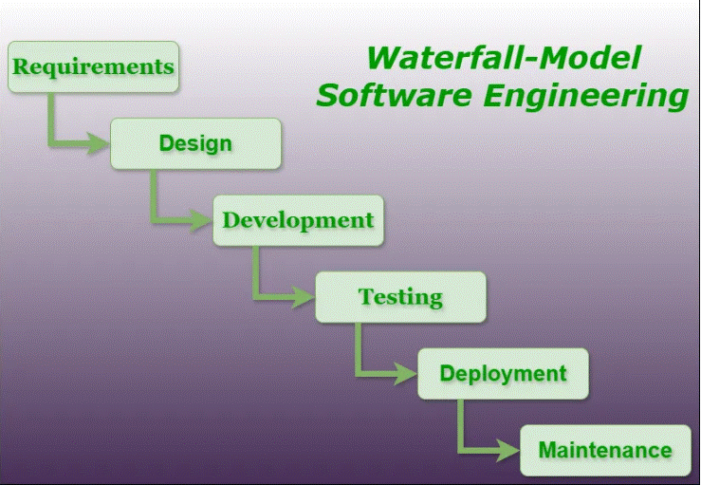
Waterfall Model-Software Engineering
Let us now learn about each of these phases in detail which include further phases.

1. Feasibility Study:
The main goal of this phase is to determine whether it would be financially and technically feasible to develop the software.
The feasibility study involves understanding the problem and then determining the various possible strategies to solve the problem. These different identified solutions are analyzed based on their benefits and drawbacks, The best solution is chosen and all the other phases are carried out as per this solution strategy.

2. Requirements Analysis and Specification:
The requirement analysis and specification phase aims to understand the exact requirements of the customer and document them properly. This phase consists of two different activities.
- Requirement gathering and analysis: Firstly all the requirements regarding the software are gathered from the customer and then the gathered requirements are analyzed. The goal of the analysis part is to remove incompleteness (an incomplete requirement is one in which some parts of the actual requirements have been omitted) and inconsistencies (an inconsistent requirement is one in which some part of the requirement contradicts some other part).
- Requirement specification: These analyzed requirements are documented in a software requirement specification (SRS) document. SRS document serves as a contract between the development team and customers. Any future dispute between the customers and the developers can be settled by examining the SRS document.

3. Design:
The goal of this phase is to convert the requirements acquired in the SRS into a format that can be coded in a programming language. It includes high-level and detailed design as well as the overall software architecture. A Software Design Document is used to document all of this effort (SDD).

4. Coding and Unit Testing:
In the coding phase software design is translated into source code using any suitable programming language. Thus each designed module is coded. The unit testing phase aims to check whether each module is working properly or not.

5. Integration and System testing:
Integration of different modules is undertaken soon after they have been coded and unit tested. Integration of various modules is carried out incrementally over several steps. During each integration step, previously planned modules are added to the partially integrated system and the resultant system is tested. Finally, after all the modules have been successfully integrated and tested, the full working system is obtained and system testing is carried out on this.
System testing consists of three different kinds of testing activities as described below.
- Alpha testing: Alpha testing is the system testing performed by the development team.
- Beta testing: Beta testing is the system testing performed by a friendly set of customers.
- Acceptance testing: After the software has been delivered, the customer performs acceptance testing to determine whether to accept the delivered software or reject it.

6. Maintenance:
Maintenance is the most important phase of a software life cycle. The effort spent on maintenance is 60% of the total effort spent to develop a full software. There are three types of maintenance.
- Corrective Maintenance: This type of maintenance is carried out to correct errors that were not discovered during the product development phase.
- Perfective Maintenance: This type of maintenance is carried out to enhance the functionalities of the system based on the customer’s request.
- Adaptive Maintenance: Adaptive maintenance is usually required for porting the software to work in a new environment such as working on a new computer platform or with a new operating system.

Advantages of the SDLC Waterfall Model
The classical waterfall model is an idealistic model for software development. It is very simple, so it can be considered the basis for other software development life cycle models. Below are some of the major advantages of this SDLC model.
- Easy to Understand: The Classical Waterfall Model is very simple and easy to understand.
- Individual Processing: Phases in the Classical Waterfall model are processed one at a time.
- Properly Defined: In the classical waterfall model, each stage in the model is clearly defined.
- Clear Milestones: The classical Waterfall model has very clear and well-understood milestones.
- Properly Documented: Processes, actions, and results are very well documented.
- Reinforces Good Habits: The Classical Waterfall Model reinforces good habits like define-before-design and design-before-code.
- Working: Classical Waterfall Model works well for smaller projects and projects where requirements are well understood.

Disadvantages of the SDLC Waterfall Model
The Classical Waterfall Model suffers from various shortcomings we can’t use it in real projects, but we use other software development lifecycle models which are based on the classical waterfall model. Below are some major drawbacks of this model.
- No Feedback Path: In the classical waterfall model evolution of software from one phase to another phase is like a waterfall. It assumes that no error is ever committed by developers during any phase. Therefore, it does not incorporate any mechanism for error correction.
- Difficult to accommodate Change Requests: This model assumes that all the customer requirements can be completely and correctly defined at the beginning of the project, but the customer’s requirements keep on changing with time. It is difficult to accommodate any change requests after the requirements specification phase is complete.
- No Overlapping of Phases: This model recommends that a new phase can start only after the completion of the previous phase. But in real projects, this can’t be maintained. To increase efficiency and reduce cost, phases may overlap.
- Limited Flexibility: The Waterfall Model is a rigid and linear approach to software development, which means that it is not well-suited for projects with changing or uncertain requirements. Once a phase has been completed, it is difficult to make changes or go back to a previous phase.
- Limited Stakeholder Involvement: The Waterfall Model is a structured and sequential approach, which means that stakeholders are typically involved in the early phases of the project (requirements gathering and analysis) but may not be involved in the later phases (implementation, testing, and deployment).
- Late Defect Detection: In the Waterfall Model, testing is typically done toward the end of the development process. This means that defects may not be discovered until late in the development process, which can be expensive and time-consuming to fix.
- Lengthy Development Cycle: The Waterfall Model can result in a lengthy development cycle, as each phase must be completed before moving on to the next. This can result in delays and increased costs if requirements change or new issues arise.

When to Use the SDLC Waterfall Model?
Here are some cases where the use of the Waterfall Model is best suited:
- Well-understood Requirements: Before beginning development, there are precise, reliable, and thoroughly documented requirements available.
- Very Little Changes Expected: During development, very little adjustments or expansions to the project’s scope are anticipated.
- Small to Medium-Sized Projects: Ideal for more manageable projects with a clear development path and little complexity.
- Predictable: Projects that are predictable, low-risk, and able to be addressed early in the development life cycle are those that have known, controllable risks.
- Regulatory Compliance is Critical: Circumstances in which paperwork is of utmost importance and stringent regulatory compliance is required.
- Client Prefers a Linear and Sequential Approach: This situation describes the client’s preference for a linear and sequential approach to project development.
- Limited Resources: Projects with limited resources can benefit from a set-up strategy, which enables targeted resource allocation.
The Waterfall approach involves little client engagement in the product development process. The product can only be shown to end consumers when it is ready.

Applications of SDLC Waterfall Model
- Large-scale Software Development Projects: The Waterfall Model is often used for large-scale software development projects, where a structured and sequential approach is necessary to ensure that the project is completed on time and within budget.
- Safety-Critical Systems: The Waterfall Model is often used in the development of safety-critical systems, such as aerospace or medical systems, where the consequences of errors or defects can be severe.
- Government and Defense Projects: The Waterfall Model is also commonly used in government and defense projects, where a rigorous and structured approach is necessary to ensure that the project meets all requirements and is delivered on time.
- Projects with well-defined Requirements: The Waterfall Model is best suited for projects with well-defined requirements, as the sequential nature of the model requires a clear understanding of the project objectives and scope.
- Projects with Stable Requirements: The Waterfall Model is also well-suited for projects with stable requirements, as the linear nature of the model does not allow for changes to be made once a phase has been completed.
For more, you can refer to the Uses of Waterfall Model.

Prototype Model
The prototype model requires that before carrying out the development of actual software, a working prototype of the system should be built. A prototype is a toy implementation of the system. A prototype usually turns out to be a very crude version of the actual system, possible exhibiting limited functional capabilities, low reliability, and inefficient performance as compared to actual software. In many instances, the client only has a general view of what is expected from the software product. In such a scenario where there is an absence of detailed information regarding the input to the system, the processing needs, and the output requirement, the prototyping model may be employed.
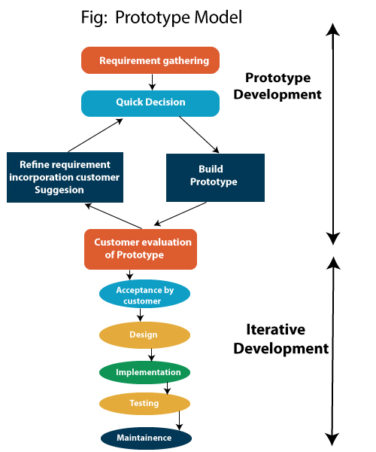

Steps of Prototype Model
- Requirement Gathering and Analyst
- Quick Decision
- Build a Prototype
- Assessment or User Evaluation
- Prototype Refinement
- Engineer Product

Advantage of Prototype Model
- Reduce the risk of incorrect user requirement
- Good where requirement are changing/uncommitted
- Regular visible process aids management
- Support early product marketing
- Reduce Maintenance cost.
- Errors can be detected much earlier as the system is made side by side.

Disadvantage of Prototype Model
- An unstable/badly implemented prototype often becomes the final product.
- Require extensive customer collaboration
  - Costs customer money
  - Needs committed customer
  - Difficult to finish if customer withdraw
  - May be too customer specific, no broad market
- Difficult to know how long the project will last.
- Easy to fall back into the code and fix without proper requirement analysis, design, customer evaluation, and feedback.
- Prototyping tools are expensive.
- Special tools & techniques are required to build a prototype.
- It is a time-consuming process.

RAD (Rapid Application Development) Model
RAD is a linear sequential software development process model that emphasizes a concise development cycle using an element-based construction approach. If the requirements are well understood and described, and the project scope is a constraint, the RAD process enables a development team to create a fully functional system within a concise time period.
RAD (Rapid Application Development) is a concept that products can be developed faster and of higher quality through:
- Gathering requirements using workshops or focus groups
- Prototyping and early, reiterative user testing of designs
- The re-use of software components
- A rigidly paced schedule that refers design improvements to the next product version
- Less formality in reviews and other team communication
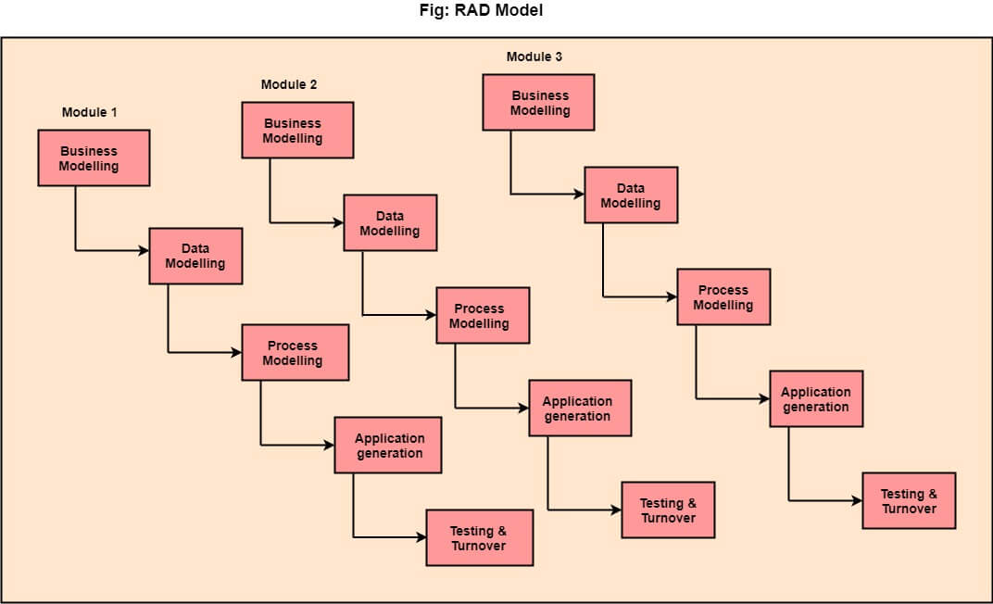

The various phases of RAD are as follows:
1.Business Modelling: The information flow among business functions is defined by answering questions like what data drives the business process, what data is generated, who generates it, where does the information go, who process it and so on.
2. Data Modelling: The data collected from business modeling is refined into a set of data objects (entities) that are needed to support the business. The attributes (character of each entity) are identified, and the relation between these data objects (entities) is defined.
3. Process Modelling: The information object defined in the data modeling phase are transformed to achieve the data flow necessary to implement a business function. Processing descriptions are created for adding, modifying, deleting, or retrieving a data object.
4. Application Generation: Automated tools are used to facilitate construction of the software; even they use the 4th GL techniques.
5. Testing & Turnover: Many of the programming components have already been tested since RAD emphasis reuse. This reduces the overall testing time. But the new part must be tested, and all interfaces must be fully exercised.

When to use RAD Model?
- When the system should need to create the project that modularizes in a short span time (2-3 months).
- When the requirements are well-known.
- When the technical risk is limited.
- When there's a necessity to make a system, which modularized in 2-3 months of period.
- It should be used only if the budget allows the use of automatic code generating tools.

Advantage of RAD Model
- This model is flexible for change.
- In this model, changes are adoptable.
- Each phase in RAD brings highest priority functionality to the customer.
- It reduced development time.
- It increases the reusability of features.

Disadvantage of RAD Model
- It required highly skilled designers.
- All application is not compatible with RAD.
- For smaller projects, we cannot use the RAD model.
- On the high technical risk, it's not suitable.
- Required user involvement.

evolutionary Model – Software Engineering

The evolutionary model is a combination of the Iterative and Incremental models of the software development life cycle. Delivering your system in a big bang release, delivering it in incremental process over time is the action done in this model. Some initial requirements and architecture envisioning need to be done. It is better for software products that have their feature sets redefined during development because of user feedback and other factors. This article focuses on discussing the Evolutionary Model in detail.

What is the Evolutionary Model?
The Evolutionary development model divides the development cycle into smaller, incremental waterfall models in which users can get access to the product at the end of each cycle.
- Feedback is provided by the users on the product for the planning stage of the next cycle and the development team responds, often by changing the product, plan, or process.
- Therefore, the software product evolves with time.
- All the models have the disadvantage that the duration of time from the start of the project to the delivery time of a solution is very high.
- The evolutionary model solves this problem with a different approach.
- The evolutionary model suggests breaking down work into smaller chunks, prioritizing them, and then delivering those chunks to the customer one by one.
- The number of chunks is huge and is the number of deliveries made to the customer.
- The main advantage is that the customer’s confidence increases as he constantly gets quantifiable goods or services from the beginning of the project to verify and validate his requirements.
- The model allows for changing requirements as well as all work is broken down into maintainable work chunks.
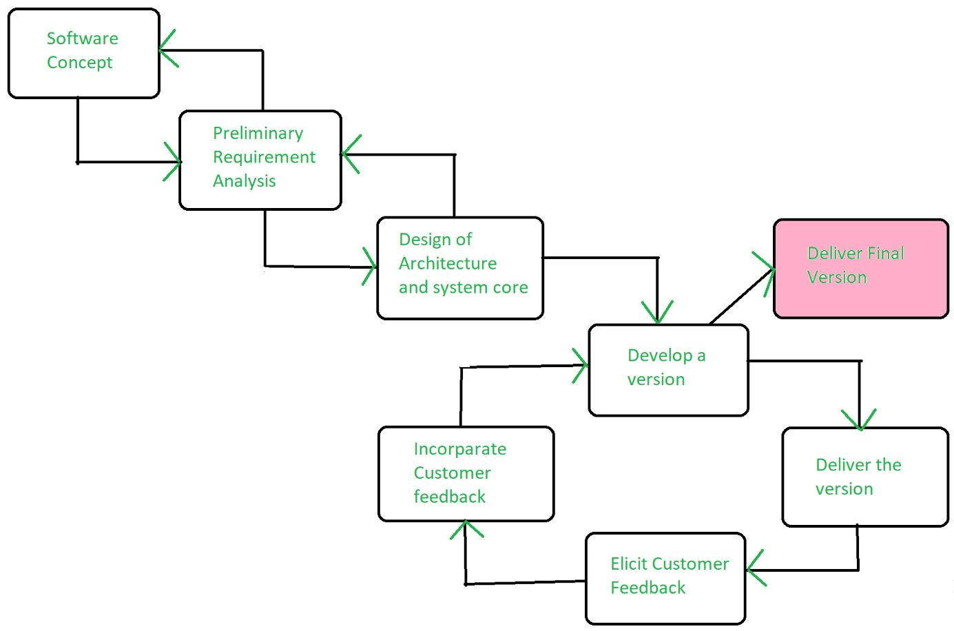
Evolutionary Model

Application of Evolutionary Model
- It is used in large projects where you can easily find modules for incremental implementation. Evolutionary model is commonly used when the customer wants to start using the core features instead of waiting for the full software.
- Evolutionary model is also used in object oriented software development because the system can be easily portioned into units in terms of objects.

Necessary Conditions for Implementing this Model
- Customer needs are clear and been explained in deep to the developer team.
- There might be small changes required in separate parts but not a major change.
- As it requires time, so there must be some time left for the market constraints.
- Risk is high and continuous targets to achieve and report to customer repeatedly.
- It is used when working on a technology is new and requires time to learn.

Advantages Evolutionary Model
- Adaptability to Changing Requirements: Evolutionary models work effectively in projects when the requirements are ambiguous or change often. They support adjustments and flexibility along the course of development.
- Early and Gradual Distribution: Functional components or prototypes can be delivered early thanks to incremental development. Faster user satisfaction and feedback may result from this.
- User Commentary and Involvement: Evolutionary models place a strong emphasis on ongoing user input and participation. This guarantees that the software offered closely matches the needs and expectations of the user.
- Improved Handling of Difficult Projects: Big, complex tasks can be effectively managed with the help of evolutionary models. The development process is made simpler by segmenting the project into smaller, easier-to-manage portions.

Disadvantages Evolutionary Model
- Communication Difficulties: Evolutionary models require constant cooperation and communication. The strategy may be less effective if there are gaps in communication or if team members are spread out geographically.
- Dependence on an Expert Group: A knowledgeable and experienced group that can quickly adjust to changes is needed for evolutionary models. Teams lacking experience may find it difficult to handle these model’s dynamic nature.
- Increasing Management Complexity: Complexity can be introduced by organizing and managing several increments or iterations, particularly in large projects. In order to guarantee integration and synchronization, good project management is needed.
- Greater Initial Expenditure: As evolutionary models necessitate continual testing, user feedback and prototyping, they may come with a greater starting cost. This may be a problem for projects that have limited funding.

