Sub : Advanced networking protocols

The TCP/IP (Transmission Control Protocol/Internet Protocol) suite is a collection of networking protocols that form the foundation of the internet and most modern computer networks. It defines how data is exchanged between devices, ensuring seamless communication across diverse networks.
Key Components of the TCP/IP Suite:
- Internet Layer (IP):
  - Responsible for addressing and routing data packets across networks.
  - Uses IP addresses to uniquely identify devices.
  - Employs routing protocols to determine the best path for data delivery.
- Transport Layer (TCP & UDP):
  - Handles end-to-end communication between applications.
  - TCP (Transmission Control Protocol):
    - Provides reliable, ordered, and error-checked delivery of data.
    - Establishes a connection before data transmission.
    - Commonly used for applications like web browsing (HTTP) and file transfer (FTP).
  - UDP (User Datagram Protocol):
    - Offers faster but less reliable data delivery.
    - Does not establish a connection before sending data.
    - Suitable for applications like streaming media and online games.
- Network Access Layer (Data Link Layer):
  - Deals with the physical transmission of data over the network medium (e.g., Ethernet, Wi-Fi).
  - Handles error detection and correction at the physical layer.
- Application Layer:
  - Provides services for specific applications, such as:
    - HTTP (Hypertext Transfer Protocol) for web browsing
    - SMTP (Simple Mail Transfer Protocol) for email
    - FTP (File Transfer Protocol) for file transfer ¹
    - DNS (Domain Name System) for translating domain names to IP addresses
How TCP/IP Works:
- Data Segmentation: Application data is divided into smaller packets called IP datagrams.
- Addressing: Each datagram is assigned a source and destination IP address.
- Routing: Routers use routing tables to forward datagrams towards their destination.
- Transmission: Datagrams are transmitted across the network using various physical media.
- Reassembly: At the destination, the received datagrams are reassembled into the original data.
Key Advantages of TCP/IP:
- Flexibility: Supports a wide range of network topologies and technologies.
- Scalability: Can accommodate a growing number of devices and networks.
- Interoperability: Enables communication between different types of devices and operating systems.
- Modularity: Allows for the addition of new protocols and services.

Routing in the Internet:
Routing is the cornerstone of the internet, enabling seamless communication between devices across vast networks. It involves the process of selecting the optimal path for data packets to travel from a source to a destination. In the complex landscape of the internet, advanced networking protocols play a crucial role in ensuring efficient and reliable routing.
Key Concepts in Internet Routing
Intra Domain Routings :-
- Autonomous System (AS): A collection of networks under a single administrative entity.
- Interior Gateway Protocols (IGPs): Used for routing within an AS. Examples include:
  - RIP (Routing Information Protocol): A distance-vector protocol that calculates the shortest path based on hop count.
  - OSPF (Open Shortest Path First): A link-state protocol that calculates the shortest path based on link costs.
  - EIGRP (Enhanced Interior Gateway Routing Protocol): A hybrid protocol that combines the features of distance-vector and link-state protocols.
Inter Domain Routings :-
- Exterior Gateway Protocols (EGPs): Used for routing between ASes. Examples include:
  - BGP (Border Gateway Protocol): The de facto standard for inter-domain routing. It considers factors like policy, path length, and network availability.

Advanced Routing Protocols and Techniques
- Quality of Service (QoS) Routing: Prioritizes certain types of traffic, such as real-time applications like voice and video, over others.
- Multicast Routing: Efficiently delivers data to multiple destinations simultaneously.
- Policy-Based Routing: Allows network administrators to control traffic flow based on specific criteria, such as source/destination IP addresses, protocols, or applications.
- MPLS (Multiprotocol Label Switching): A high-performance switching technique that forwards packets based on short labels, reducing processing overhead.
- SDN (Software-Defined Networking): Centralizes network control, enabling dynamic and programmable routing.
Challenges and Future Trends
- Scalability: As the internet grows, routing protocols must adapt to handle increasing network complexity.
- Security: Protecting routing protocols from attacks like routing hijacking and poisoning is critical.
- Automation: Automating routing configurations can reduce human error and improve network agility.
- AI/ML: Leveraging AI and machine learning for intelligent routing decisions, such as predicting traffic patterns and optimizing network performance.
Visualizing Internet Routing
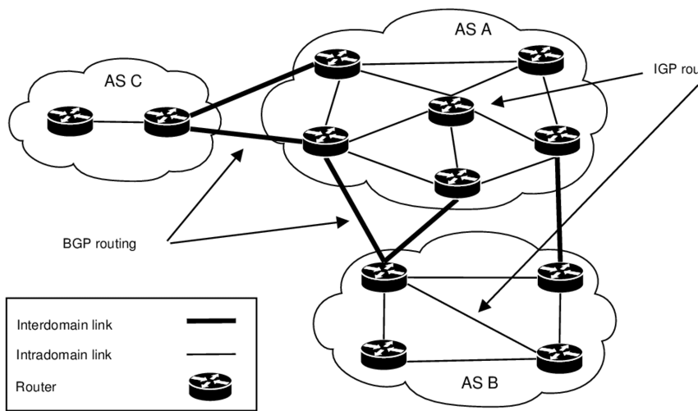
• Intra-domain routing is like finding the best routes within a city.
• Inter-domain routing is like finding the best routes between different cities, considering factors like road conditions, tolls, and traffic.
Unicast Routing Protocols
- Definition: These protocols determine the best path for data to travel from a single source to a single destination within a network.
- Key Characteristics:
  - One-to-one communication: Data is sent from one specific device to another specific device.
  - Examples:
    - RIP (Routing Information Protocol): A distance-vector protocol that broadcasts routing information periodically.
    - OSPF (Open Shortest Path First): A link-state protocol that shares complete topology information with all routers in the network.
    - EIGRP (Enhanced Interior Gateway Routing Protocol): A hybrid protocol that combines features of both distance-vector and link-state protocols.
    - BGP (Border Gateway Protocol): The industry-standard protocol for inter-domain routing (between different autonomous systems).
Multicast Routing Protocols
- Definition: These protocols efficiently deliver data from a single source to multiple destinations simultaneously.
- Key Characteristics:
  - One-to-many communication: Data is sent from one device to a group of devices that have expressed interest in receiving it.
  - Efficiency: Reduces network traffic compared to sending multiple unicast packets.
  - Examples:
    - Protocol Independent Multicast (PIM): A suite of protocols that includes PIM-SM (Sparse Mode) and PIM-DM (Dense Mode) for different network topologies.
    - Multicast Source Discovery Protocol (MSDP): Helps routers discover multicast sources across autonomous systems.
Key Differences
Feature | Unicast Routing | Multicast Routing
Communication Type | One-to-one | One-to-many
Efficiency | Less efficient for multiple destinations | More efficient for multiple destinations
Traffic | Generates more traffic for multiple destinations | Reduces traffic for multiple destinations
Protocols | RIP, OSPF, EIGRP, BGP | PIM, MSDP
Export to Sheets

Unit II

Introduction to Networking Management Services
Networking management services are a suite of tools and techniques used to monitor, control, and optimize the performance of a computer network. These services are essential for ensuring that a network operates smoothly, efficiently, and securely.

Key Components of Networking Management Services
- Network Monitoring: This involves continuously tracking network performance metrics, such as bandwidth usage, latency, and packet loss. Monitoring tools can alert administrators to potential problems before they become major issues.
- Network Configuration and Management: This includes managing network devices, such as routers, switches, and firewalls, as well as configuring network protocols and services.
- Network Security: This involves implementing security measures to protect the network from threats, such as unauthorized access, malware, and denial-of-service attacks.
- Network Troubleshooting: This involves identifying and resolving network problems, such as slow performance, connectivity issues, and security breaches.
- Network Optimization: This involves fine-tuning network settings to improve performance and efficiency.

Benefits of Networking Management Services
- Improved Network Performance: By monitoring network performance and identifying bottlenecks, networking management services can help to improve network speed and reliability.
- Enhanced Security: Network security measures can help to protect sensitive data and prevent unauthorized access to the network.
- Reduced Downtime: By proactively identifying and resolving network problems, networking management services can help to minimize downtime and disruptions to business operations.
- Cost Savings: By optimizing network usage and reducing the need for manual intervention, networking management services can help to reduce IT costs.
Standard network Management Protocol:-
The standard network management services protocol is SNMP (Simple Network Management Protocol).
- What it is: SNMP is a widely used protocol for monitoring and managing network devices. It allows network administrators to:
  - Collect information: Gather data about network devices, such as CPU usage, memory utilization, interface statistics, and more.
  - Configure devices: Modify settings on network devices remotely, such as changing IP addresses, adjusting bandwidth limits, and updating firmware.
  - Detect and troubleshoot problems: Identify and isolate network issues, such as device failures, traffic congestion, and security breaches.
- How it works:
  - Manager-Agent architecture: SNMP operates in a client-server model.
    - Manager: The network management software that sends requests and receives responses.
    - Agent: Software running on the managed device (router, switch, server, etc.) that collects and provides information to the manager.
  - MIB (Management Information Base): A structured database that defines the information that can be managed for a particular device or system.
- Key features:
  - Scalability: Can manage large and complex networks.
  - Interoperability: Works with a wide range of network devices from different vendors.
  - Simplicity: Relatively easy to implement and use.
- Versions:
  - SNMPv1: The original version, with limited security.
  - SNMPv2: Introduced improvements in performance and functionality.
  - SNMPv3: The current version, with enhanced security features such as authentication and encryption.

Traffic Engineering in Advanced Networking Protocols:
What is Traffic Engineering?
Networking share data in packet form that is traffic .
In the realm of advanced networking, traffic engineering refers to a set of techniques and strategies aimed at optimizing the flow of data across a network. It involves intelligent management of network resources to ensure efficient, reliable, and cost-effective data transmission.
Traffic Engineering Important?
- Increased Network Performance: By carefully controlling traffic flow, traffic engineering helps to reduce congestion, minimize delays, and maximize throughput. This leads to a better user experience, especially for applications sensitive to latency or jitter.
- Improved Resource Utilization: Traffic engineering allows network operators to efficiently utilize available bandwidth and other resources, preventing bottlenecks and ensuring that critical traffic flows are prioritized.
- Enhanced Network Reliability: By distributing traffic load across multiple paths, traffic engineering can improve fault tolerance and reduce the impact of network failures.
- Reduced Operational Costs: By optimizing resource utilization and minimizing congestion, traffic engineering can help reduce the need for costly network upgrades and maintenance.
Key Techniques and Technologies
- Routing Protocols: Advanced routing protocols like OSPF (Open Shortest Path First) and IS-IS (Intermediate System-to-Intermediate System) play a crucial role in traffic engineering. These protocols can be configured to influence routing decisions based on factors beyond just the shortest path, such as link capacity, traffic load, and delay.
- Multiprotocol Label Switching (MPLS): MPLS is a powerful technology that provides efficient and flexible traffic engineering capabilities. It enables the creation of virtual paths and tunnels, allowing network operators to steer traffic along specific routes and prioritize certain applications.
- Quality of Service (QoS): QoS mechanisms, such as traffic shaping and policing, can be used to prioritize critical traffic flows and ensure that they receive adequate bandwidth and low latency.
- Network Monitoring and Management Tools: Real-time monitoring and analysis of network traffic patterns are essential for effective traffic engineering. Network management tools provide valuable insights into network performance and help identify potential bottlenecks.
Traffic Engineering in Advanced Networking Protocols
- MPLS Traffic Engineering (MPLS TE): MPLS TE leverages MPLS to create dedicated paths for traffic flows, allowing for fine-grained control over routing and resource allocation.
- Segment Routing (SR): SR is an emerging technology that extends the capabilities of MPLS by allowing routers to make routing decisions based on a sequence of segments, rather than just hop-by-hop information. This provides greater flexibility and scalability for traffic engineering.
- Software-Defined Networking (SDN): SDN decouples the control plane from the data plane, enabling centralized and programmable control over network traffic. This provides a powerful platform for implementing sophisticated traffic engineering algorithms and policies.

• T.E Sizing:
- Capacity Planning: Estimating future traffic demands to ensure adequate bandwidth, processing power, and storage capacity.
- Link Dimensioning: Determining the appropriate bandwidth and other link characteristics (e.g., latency, jitter) for different segments of the network.
- Resource Allocation: Distributing network resources (bandwidth, processing power) efficiently among different traffic flows.
T.E Characteristics:
- Predictive: Anticipating future traffic patterns and proactively adjusting network configurations.
- Adaptive: Dynamically responding to real-time traffic changes and network conditions.
- Intelligent: Utilizing advanced algorithms and AI/ML techniques for intelligent traffic routing and optimization.
T.E Protocols:
- MPLS (Multiprotocol Label Switching): Provides efficient and flexible traffic engineering capabilities, including traffic engineering routes (TE routes) and constraint-based routing (CBR).
- BGP (Border Gateway Protocol): Enables inter-domain routing and can be extended with traffic engineering extensions like BGP FlowSpec and BGP Communities.
- OSPF (Open Shortest Path First): An interior gateway protocol that supports traffic engineering features like link weights and area boundaries.
- IS-IS (Intermediate System-to-Intermediate System): Another interior gateway protocol with traffic engineering capabilities, including link weights and level-1/level-2 areas.
- SDN (Software-Defined Networking): Provides a centralized control plane for network management, enabling fine-grained traffic engineering and dynamic network reconfiguration.
T.E Time Delay:
- Minimizing Latency: Advanced protocols like MPLS (Multiprotocol Label Switching) and SDN (Software-Defined Networking) enable fine-grained control over traffic flow, allowing for the selection of paths with minimal latency. This is crucial for real-time applications like voice and video conferencing.
- QoS (Quality of Service): Techniques like DiffServ (Differentiated Services) and IntServ (Integrated Services) can prioritize traffic based on delay sensitivity, ensuring that time-critical data reaches its destination with minimal delay.
T.E Connectivity:
- Multipath Routing: Advanced protocols can leverage multiple paths for traffic flow, increasing redundancy and fault tolerance. In case of link failures, traffic can be rerouted seamlessly, maintaining connectivity.
- Network Virtualization: Technologies like VXLAN (Virtual Extensible LAN) and VTEP (Virtual Tunnel Endpoint) enable the creation of virtual networks within a physical network, enhancing connectivity and isolation for different applications.
T.E Availability:
- Redundancy and Fault Tolerance: As mentioned earlier, multipath routing and link redundancy mechanisms contribute significantly to network availability.
- Fast Failure Detection and Recovery: Advanced protocols incorporate mechanisms for rapid detection and recovery from failures, minimizing service disruptions.
T.E Reliability:
- Error Detection and Correction: Protocols like TCP (Transmission Control Protocol) employ error detection and correction mechanisms to ensure data integrity.
- Link State Information: Protocols like OSPF (Open Shortest Path First) and IS-IS (Intermediate System-to-Intermediate System) maintain and disseminate link state information, enabling proactive routing adjustments in case of failures.
T.E Maintainability:
- Centralized Management: SDN architectures provide centralized control over network resources, simplifying network management and maintenance tasks.
- Automation and Orchestration: Advanced protocols can be automated and orchestrated using tools like YANG (Yet Another Next Generation) and NETCONF (Network Configuration Protocol), reducing manual intervention and human error
T.E Throughput calculation :
- Throughput is the amount of data that can be successfully transmitted over a network connection within a specific timeframe. It's typically measured in bits per second (bps), kilobits per second (kbps), megabits per second (Mbps), or gigabits per second (Gbps).

Unit III
- Multimedia Over Internet :
Intoduction to Multimedia Services :

Multimedia services have revolutionized how we communicate, entertain, and learn. In the realm of advanced networking protocols, these services demand specialized considerations to ensure smooth and high-quality delivery.
Key Characteristics of Multimedia Services:
- Real-time Sensitivity: Many multimedia applications, such as voice calls, video conferencing, and live streaming, require real-time delivery with minimal delay and jitter (variations in packet arrival times).
- High Bandwidth Requirements: Audio, video, and other multimedia content often consume significant bandwidth, necessitating efficient network utilization and potential Quality of Service (QoS) mechanisms.
- Diverse Content Types: Multimedia encompasses various formats, including audio, video, images, and even 3D models, each with unique characteristics and transmission needs.
Challenges in Delivering Multimedia Services:
- Network Congestion: Contention for network resources from various applications can lead to delays, packet loss, and degraded quality of experience for multimedia users.
- Jitter and Latency: Variations in packet arrival times and delays can significantly impact the quality of real-time multimedia applications, such as voice calls and video conferences.
- Bandwidth Variability: Network bandwidth can fluctuate, affecting the quality of multimedia streams.
Advanced Networking Protocols for Multimedia:
To address these challenges, advanced networking protocols have been developed:
- Real-time Transport Protocol (RTP): A standardized protocol for delivering multimedia data over IP networks. It provides mechanisms for synchronization, quality monitoring, and payload type identification.
- Real-time Transport Control Protocol (RTCP): A companion protocol to RTP that provides feedback on the quality of media delivery, including packet loss and jitter.
- Resource Reservation Protocol (RSVP): A signaling protocol that allows applications to reserve resources (bandwidth, buffer space) across a network, ensuring predictable performance for real-time traffic.
- Quality of Service (QoS) Mechanisms: Techniques like traffic shaping, prioritization, and resource reservation are employed to ensure that multimedia traffic receives the necessary bandwidth and low latency.
Applications of Multimedia Services:
- Video Conferencing: Enables real-time, interactive communication between individuals or groups across geographical distances.
- Streaming Media: Allows users to access and consume audio and video content on demand or live.
- Voice over IP (VoIP): Enables voice communication over IP networks, offering cost-effective alternatives to traditional phone services.
- Telemedicine: Facilitates remote healthcare services, including consultations, diagnostics, and even surgeries.
- Distance Learning: Enables interactive learning experiences, including virtual classrooms and online courses.

Advanced Networking Protocols for Multimedia Transmission over the Internet
Multimedia transmission over the internet presents unique challenges due to its real-time nature, high bandwidth requirements, and sensitivity to delays and jitter. Advanced networking protocols are essential to ensure smooth and high-quality multimedia experiences. Here are some key protocols and techniques:
1. Real-time Transport Protocol (RTP) and Real-time Transport Control Protocol (RTCP):
- RTP: Handles the actual delivery of multimedia data (audio, video, etc.) in packets. It provides features like synchronization, sequence numbering, and payload type identification.
- RTCP: Monitors the quality of the RTP data stream and provides feedback to the sender. It also enables participants to learn about each other.
2. Session Initiation Protocol (SIP):
- Used for establishing, modifying, and tearing down multimedia sessions.
- It allows users to register their availability, initiate calls, and manage sessions.
3. Quality of Service (QoS) Mechanisms:
- Differentiated Services (DiffServ): Provides different levels of service to different types of traffic based on their priority.
- Integrated Services (IntServ): Offers more strict QoS guarantees by reserving resources for specific flows.
- Resource Reservation Protocol (RSVP): Used to request and reserve resources for IntServ.
4. Multicast Protocols:
- Allow efficient delivery of data to multiple recipients simultaneously.
- Examples include Protocol Independent Multicast (PIM) and Internet Group Management Protocol (IGMP).
5. Compression Techniques:
- Reduce the size of multimedia data to minimize bandwidth requirements.
- Common codecs include H.264/AVC for video and AAC for audio.
6. Forward Error Correction (FEC):
- Adds redundancy to the transmitted data to enable error recovery at the receiver.
- Reduces the need for retransmissions, which can introduce delays.
7. Network Address Translation (NAT) Traversal:
- Enables communication between devices behind NAT firewalls.
- Techniques include STUN, TURN, and ICE.

IP Multicasting:
IP multicasting is a powerful networking technique that allows a sender to efficiently transmit data to a group of receivers simultaneously. This is achieved by using special IP addresses called multicast addresses, which represent a group of destinations rather than a single host.
Key Concepts:
- Multicast Addresses: These are special IP addresses that identify a group of receivers. They are typically Class D addresses in IPv4 (224.0.0.0 to 239.255.255.255) and a specific range in IPv6.
- Multicast Groups: A collection of receivers interested in receiving data from a particular multicast source.
- Multicast Routing: The process of forwarding multicast packets efficiently across the network. Routers use protocols like Protocol Independent Multicast (PIM) to build and maintain multicast trees.
- IGMP (Internet Group Management Protocol): Hosts use IGMP to inform routers about their interest in joining or leaving multicast groups.
Benefits of IP Multicasting:
- Bandwidth Efficiency: Reduces network traffic by sending a single copy of data to multiple receivers, instead of multiple unicast transmissions.
- Scalability: Can efficiently support large numbers of receivers.
- Reduced Server Load: The sender only needs to transmit data once, reducing the burden on the server.
Applications of IP Multicasting:
- Video Conferencing: Allows multiple participants to receive video and audio streams simultaneously.
- Live Streaming: Enables efficient distribution of live events like sports or concerts.
- Software Updates: Distributes software updates to multiple clients efficiently.
- Financial Data Distribution: Delivers real-time market data to subscribers.

Explaining VOIP :-
Voice over Internet Protocol (VoIP) has revolutionized communication by enabling voice calls over the internet. While the basic concept might seem simple – converting voice to digital data and transmitting it over IP networks – advanced VoIP implementations involve intricate protocols and technologies. Let's delve into some key aspects:
1. Core Protocols:
- Session Initiation Protocol (SIP):
  - The workhorse of VoIP, SIP handles call setup, teardown, and various call control functions.
  - It's a signaling protocol that allows users to locate other users, initiate sessions, and modify session parameters.
  - SIP is a text-based protocol that operates on top of the Transport Layer (TCP or UDP).
- Real-time Transport Protocol (RTP):
  - RTP is responsible for the actual delivery of real-time data, such as voice and video.
  - It provides mechanisms for synchronization, quality of service (QoS) control, and payload type identification.
  - RTP often works in conjunction with the Real-time Transport Control Protocol (RTCP), which provides feedback on the quality of the RTP data stream.
2. Advanced VoIP Technologies:
- Codec:
  - Codecs are algorithms that compress and decompress audio data, reducing bandwidth requirements.
  - Common codecs used in VoIP include G.711, G.729, and iLBC.
  - The choice of codec depends on factors like bandwidth availability, desired audio quality, and computational resources.
- Quality of Service (QoS):
  - QoS mechanisms ensure that VoIP traffic receives priority over other network traffic, minimizing jitter, latency, and packet loss.
  - Techniques like traffic shaping, prioritization, and resource reservation are used to achieve QoS.
- Network Address Translation (NAT) Traversal:
  - NAT devices can hinder VoIP communication by changing IP addresses.
  - Techniques like STUN (Session Traversal Utilities for NAT) and TURN (Traversal Using Relays around NAT) help VoIP clients to communicate through NAT devices.
3. VoIP Applications and Services:
- IP Telephony:
  - Traditional phone service delivered over IP networks, offering features like call forwarding, voicemail, and conferencing.
- Video Conferencing:
  - Real-time video and audio communication, enabling face-to-face interactions across distances.
- Unified Communications (UC):
  - A suite of communication tools, including voice, video, messaging, and presence, integrated into a single platform.

Unit IV
Bluetooth is a network technology that connects mobile devices wirelessly over a short range to form a personal area network (PAN). They use short-wavelength, ultra-high frequency (UHF) radio waves within the range 2.400 to 2.485 GHz, instead of RS-232 data cables of wired PANs.

History of Bluetooth
WLAN technology enables device connectivity to infrastructure based services through a wireless carrier provider. The need for personal devices to communicate wirelessly with one another without an established infrastructure has led to the emergence of Personal Area Networks (PANs).
- Ericsson's Bluetooth project in 1994 defines the standard for PANs to enable communication between mobile phones using low power and low cost radio interfaces.
- In May 1988, Companies such as IBM, Intel, Nokia and Toshiba joined Ericsson to form the Bluetooth Special Interest Group (SIG) whose aim was to develop a defacto standard for PANs.
- IEEE has approved a Bluetooth based standard named IEEE 802.15.1 for Wireless Personal Area Networks (WPANs). IEEE standard covers MAC and Physical layer applications.
Bluetooth specification details the entire protocol stack. Bluetooth employs Radio Frequency (RF) for communication. It makes use of frequency modulation to generate radio waves in the ISM band.

The usage of Bluetooth has widely increased for its special features.
- Bluetooth offers a uniform structure for a wide range of devices to connect and communicate with each other.
- Bluetooth technology has achieved global acceptance such that any Bluetooth enabled device, almost everywhere in the world, can be connected with Bluetooth enabled devices.
- Low power consumption of Bluetooth technology and an offered range of up to ten meters has paved the way for several usage models.
- Bluetooth offers interactive conference by establishing an adhoc network of laptops.
- Bluetooth usage model includes cordless computer, intercom, cordless phone and mobile phones.

There are two types Bluetooth network
1) Piconets

2) Scatternodes

Piconets
Piconets are small Bluetooth networks, formed by at most 8 stations, one of which is the master node and the rest slave nodes (maximum of 7 slaves). Master node is the primary station that manages the small network. The slave stations are secondary stations that are synchronized with the primary station.
Communication can take place between a master node and a slave node in either one-to-one or one-to-many manner. However, no direct communication takes place between slaves. Each station, whether master or slave, is associated with a 48-bit fixed device address.
Besides the seven active slaves, there can be up to 255 numbers of parked nodes. These are in a low power state for energy conservation. The only work that they can do is respond to a beacon frame for activation from the master node.
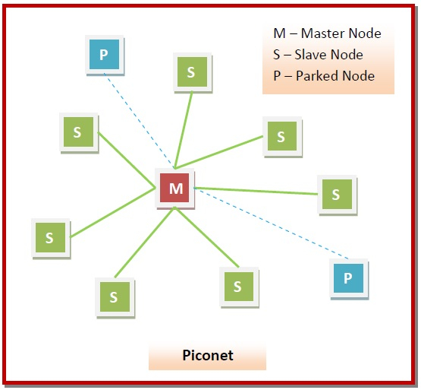

Scatternodes
A scatternet is an interconnected collection of two or more piconets. They are formed when a node in a piconet, whether a master or a slave, acts as a slave in another piconet. This node is called the bridge between the two piconets, which connects the individual piconets to form the scatternet.
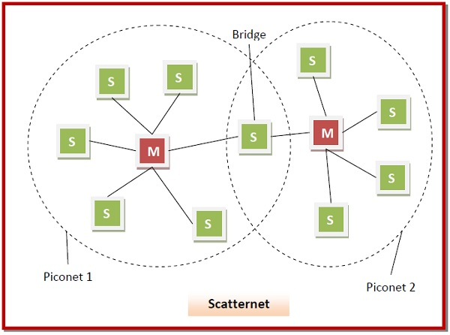

Bluetooth wireless technology is a short range communications technology intended to replace the cables connecting portable unit and maintaining high levels of security. Bluetooth technology is based on Ad-hoc technology also known as Ad-hoc Pico nets, which is a local area network with a very limited coverage.

Piconets and Scatternets
Bluetooth enabled electronic devices connect and communicate wirelessly through shortrange devices known as Piconets. Bluetooth devices exist in small ad-hoc configurations with the ability to act either as master or slave the specification allows a mechanism for master and slave to switch their roles. Point to point configuration with one master and one slave is the simplest configuration.
When more than two Bluetooth devices communicate with one another, this is called a PICONET. A Piconet can contain up to seven slaves clustered around a single master. The device that initializes establishment of the Piconet becomes the master.
The master is responsible for transmission control by dividing the network into a series of time slots amongst the network members, as a part of time division multiplexing scheme which is shown below.
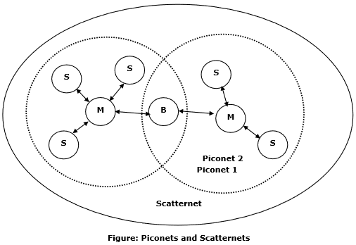
The features of Piconets are as follows −
- Within a Piconet, the timing of various devices and the frequency hopping sequence of individual devices is determined by the clock and unique 48-bit address of master.
- Each device can communicate simultaneously with up to seven other devices within a single Piconet.
- Each device can communicate with several piconets simultaneously.
- Piconets are established dynamically and automatically as Bluetooth enabled devices enter and leave piconets.
- There is no direct connection between the slaves and all the connections are essentially master-to-slave or slave-to-master.
- Slaves are allowed to transmit once these have been polled by the master.
- Transmission starts in the slave-to-master time slot immediately following a polling packet from the master.
- A device can be a member of two or more piconets, jumping from one piconet to another by adjusting the transmission regime-timing and frequency hopping sequence dictated by the master device of the second piconet.
- It can be a slave in one piconet and master in another. It however cannot be a master in more than once piconet.
- Devices resident in adjacent piconets provide a bridge to support inner-piconet connections, allowing assemblies of linked piconets to form a physically extensible communication infrastructure known as Scatternet.

Spectrum
Bluetooth technology operates in the unlicensed industrial, scientific and medical (ISM) band at 2.4 to 2.485 GHZ, using a spread spectrum hopping, full-duplex signal at a nominal rate of 1600 hops/sec. the 2.4 GHZ ISM band is available and unlicensed in most countries.

Range
Bluetooth operating range depends on the device Class 3 radios have a range of up to 1 meter or 3 feet Class 2 radios are most commonly found in mobile devices have a range of 10 meters or 30 feet Class 1 radios are used primarily in industrial use cases have a range of 100 meters or 300 feet.

Data rate
Bluetooth supports 1Mbps data rate for version 1.2 and 3Mbps data rate for Version 2.0 combined with Error Data Rate.

